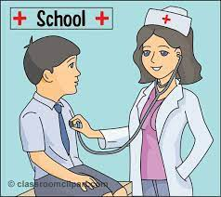**How to Print A Picture/**

**Dr. Note From Class Dojo**

Nurse Rosie mentioned some teachers wanted know how to print a doctor’s note from Class Dojo. Below are directions.

1. View the picture
2. Open a word document
3. Right click and copy the picture
4. Paste the picture on the word document

(Adjust as needed)

If the letter or image is not clear enough:

1. Click on the picture to open it
2. Take a snip (screenshot) of the picture
3. Open a word document
4. Right click and copy the screenshot to the word document

(Adjust as needed)

-From there you can print the doctor’s note or you can save it to your documents and email it to her.